VRINDA STORE ANALYSIS REPORT

**Insights from the dashboard:**

1. Women are more likely to buy as compared to men (64%)

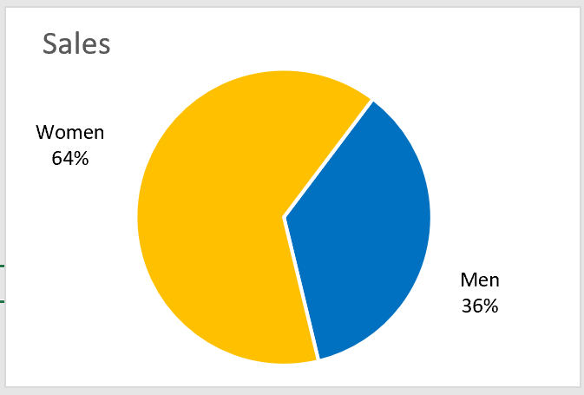

2. Maharashtra, Karnataka, and Uttar Pradesh are the top 3 states in terms of sales (35%)

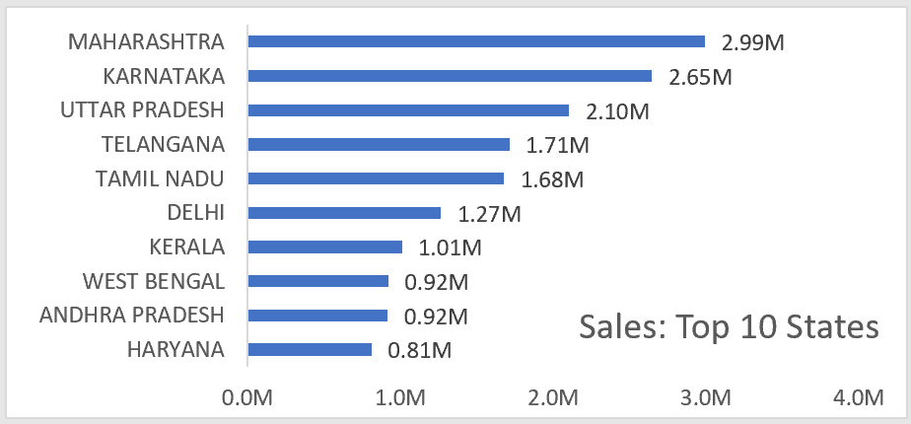

3. The adult age group (30-49 years) is the max contributing age group (50%)

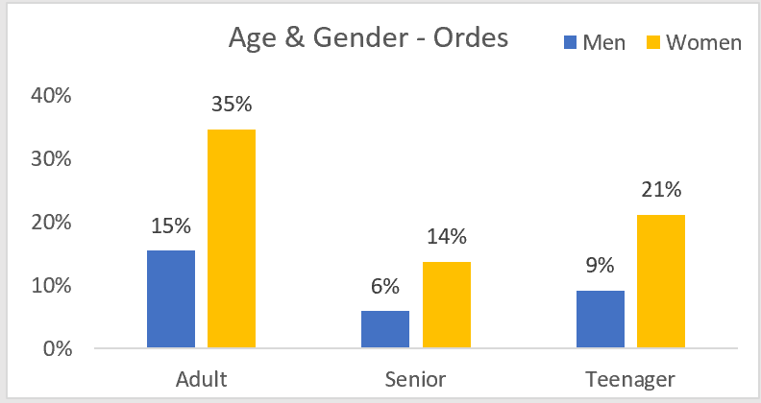

4. Amazon, Flipkart, and Myntra channels are max contributing Channels (80%)

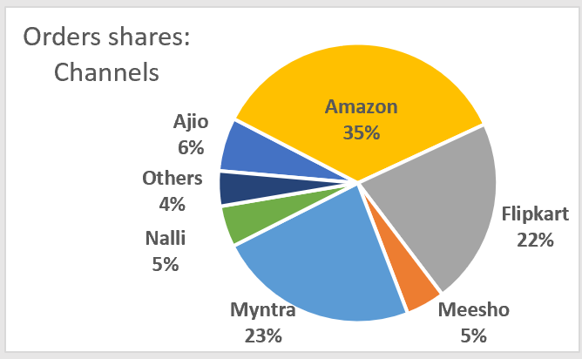

**Recommendations to improve Vrinda store sales:**

Target **Women** customers of the age group (**30-49 years**) living in **Maharashtra, Karnataka, and Uttar Pradesh** in the month of **March** by sharing them with ads/offers/coupons available on **Amazon, Flipkart, and Myntra**.

